UCTCR Discussion Questions for Video 1-1 and 1-2

Name: ________YeongJu Kwak (영주 곽)________

Please answer the following questions before the lecture to prepare for the class discussions.

1) Below, you will find a simplified family tree of Miguel. Complete your own family tree.

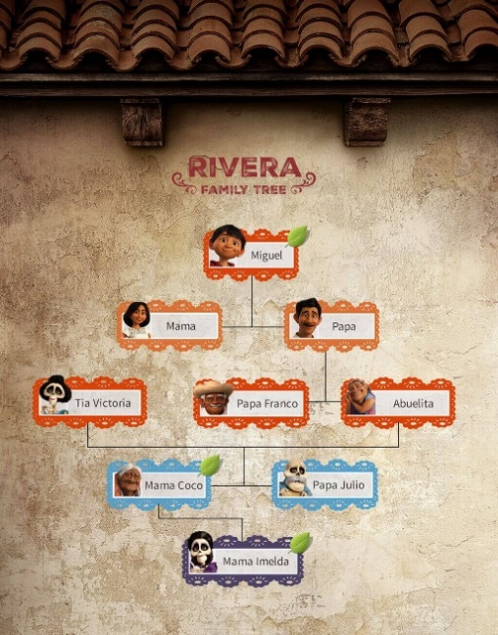 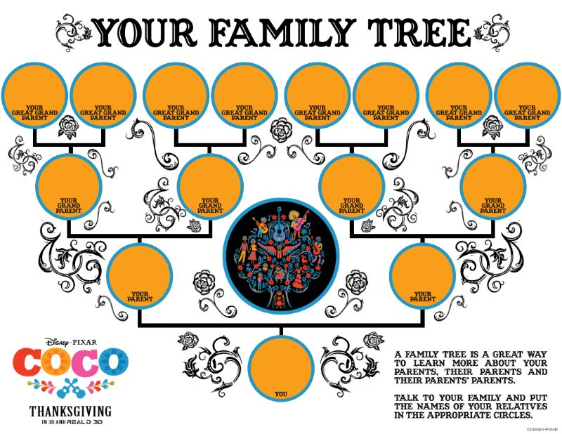

<My family tree>

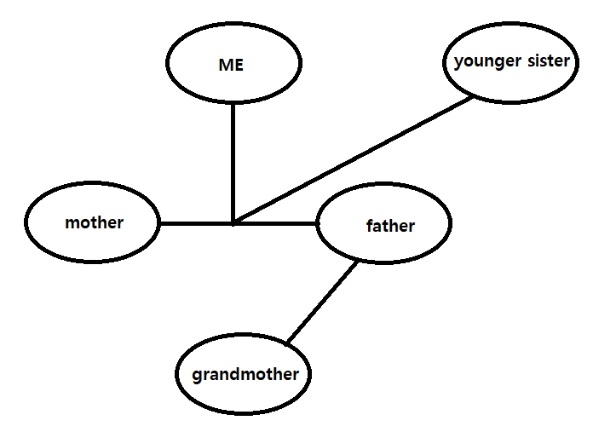

2) The movie takes place during Dia de los Muertos (the Day of the Dead). It is often compared to the American celebration of Halloween.

a) How are the two similar and different? List at least two similarities and two differences.

|  |  |
| --- | --- |
| Similarities | Differences |
| 1. The souls of the dead are awakened.  2. It is a national traditional event. | 1. On 'Day of the Dead', we remember the dead and pray for rest. However, in 'Halloween', it is believed that ghosts harm people, so people wear costumes such as skeletons and monsters to enjoy the festival.  2. In modern times, the meaning of 'Halloween' has changed. |

b) Is there a similar celebration in Korea? Describe how it is similar?

In Korea, there is Chuseok.

On Chuseok, ancestral rites are held. This has the same meaning as 'the day of the dead'.

3) Music is forbidden in Miguel’s household. Is there something that is forbidden in your household? What is it? Why is it forbidden?

Just don't do bad things.

4) Miguel does not want to inherit the family business, and instead wants to become a musician. What would you do if your parents’ plans for your future differs from your own?

My family respects my choices.

5) Mariachi music is a genre of regional Mexican music.

a) Search on Youtube for famous mariachi music and listen to one song. Then fill out the information below:

Song title: La Culebra

Name of musician(s): Mariachi Vargas de Tecalitlan

Year the song was recorded: 1958

b) Research mariachi music on Google and write out at least TWO defining characteristics of mariachi music.

1. Traditional mariachi groups are made up of two or more members, dressed in charro costumes of local colors and interpreting and performing songs from various repertoires using string instruments.

2. Modern mariachi ensembles include trumpet, violin, vihuela (a six-string instrument similar to a guitar) and guitarrón (bass guitar), with four or more players.

c) What is a traditional genre of Korean music? How does it compare to mariachi music? Describe at least one similarity and one difference.

Korean traditional music is pansori.

The similarity between pansori and mariachi allows us to know the culture of a country through music.

The difference between pansori and mariachi is that mariachi is played with two or more members and a string instrument, whereas pansori performs with two members (singer and drummer).